India’s Agricultural Crop Production Analysis(1997-2021)

* State Wise Agricultural Land
* Area vs Production
* Season based cultivation by area
* Yield by season
* Crop plantation by area
* Major crops growth Yoy
* Crops Plantation By count
* Season wise production

<https://www.kaggle.com/datasets/pyatakov/india-agriculture-crop-production>

Understand the data

Data consists of 345409 rows and 10 columns that correspond to different values.

Column Description of the Dataset:

* State : The name of the Indian states.
* District : The name of the districts of Indian states.
* Crop : Name of different crops grown in India
* Year : Date
* Season : India has 5 seasons for crop cultivation: kharif, rabi, autumn, winter and summer.
* Area: Area for crop cultivation in acres
* Production : Production of crops in tonnes
* Yield : Yield by the crops under cultivation

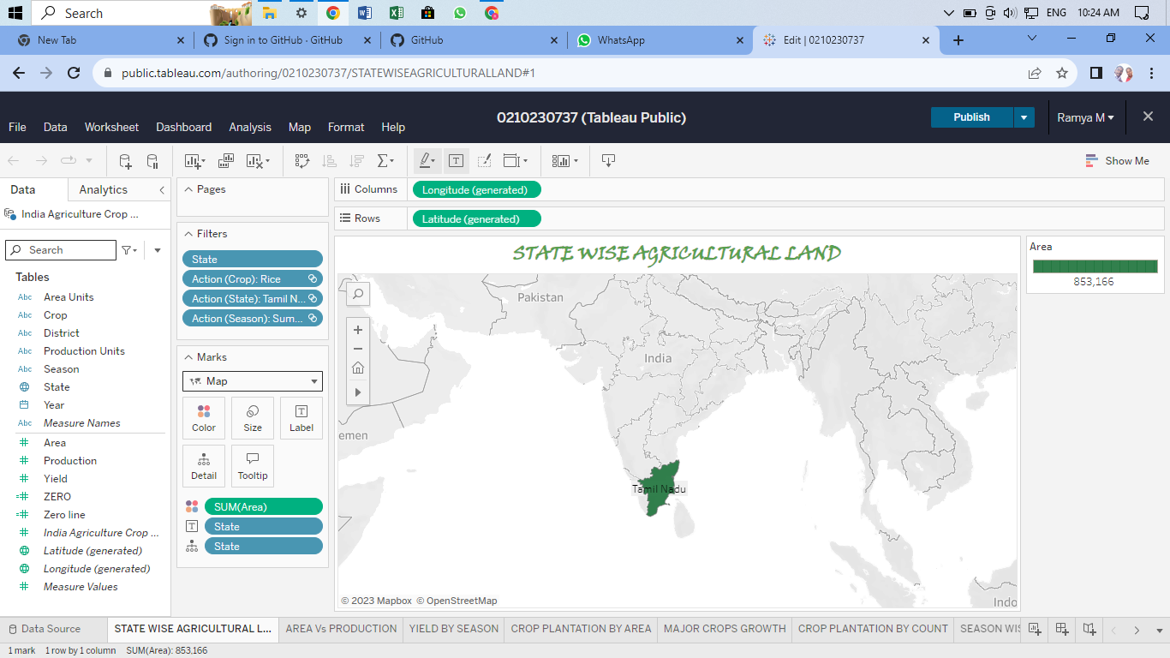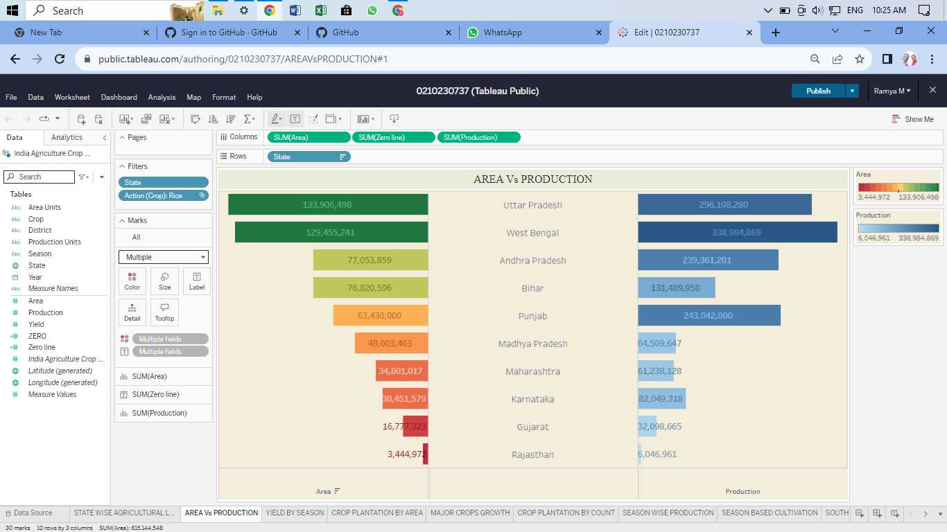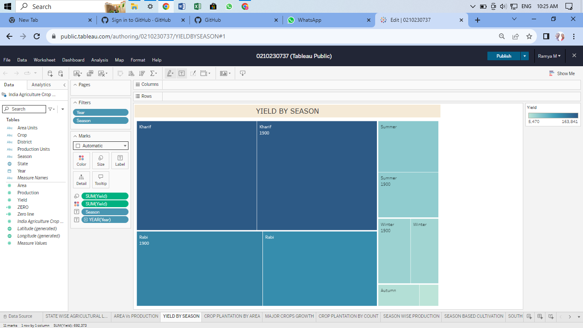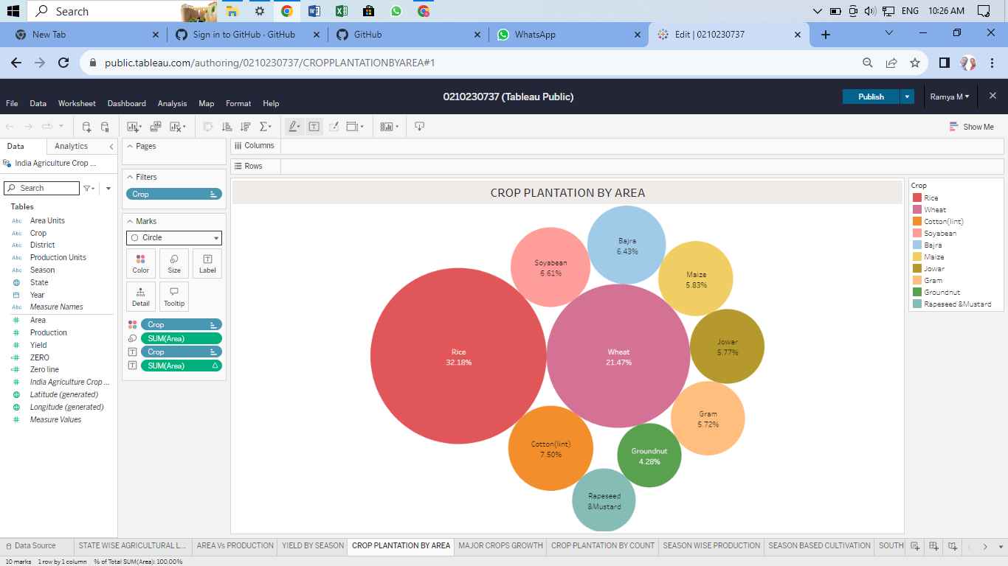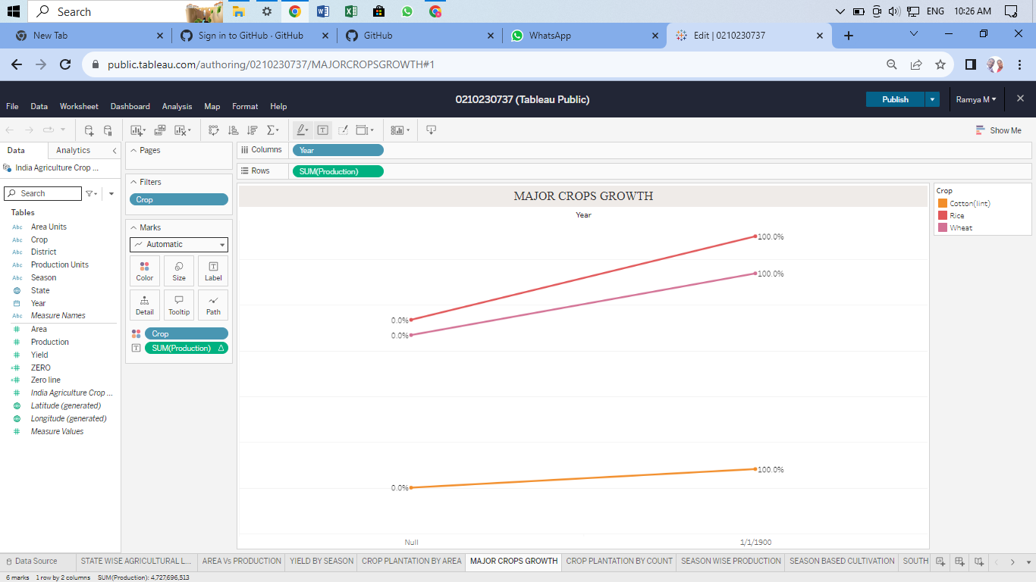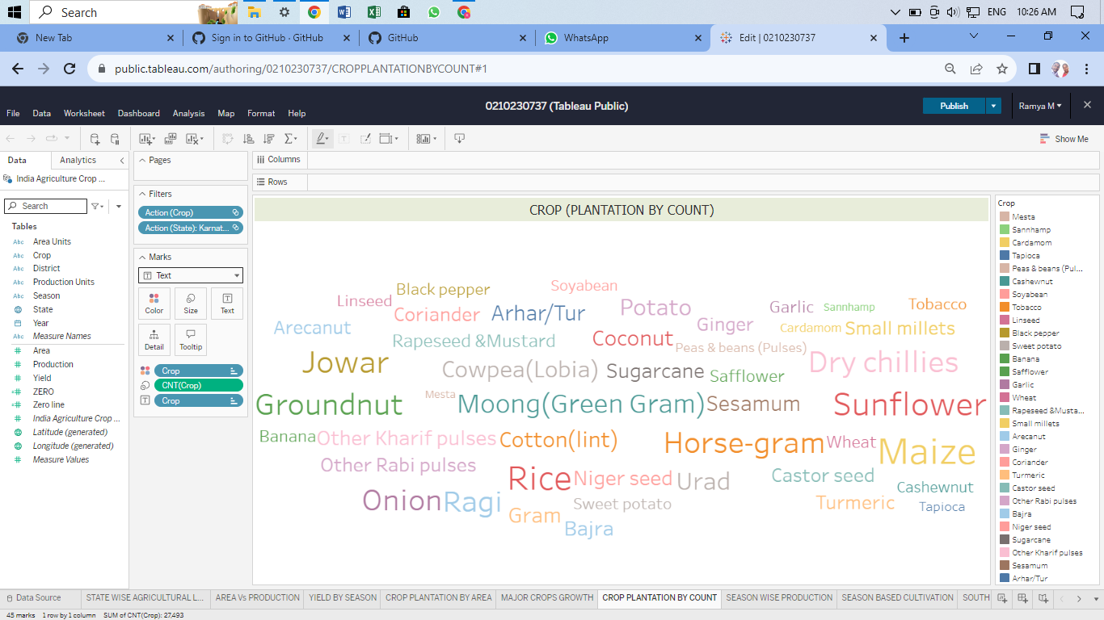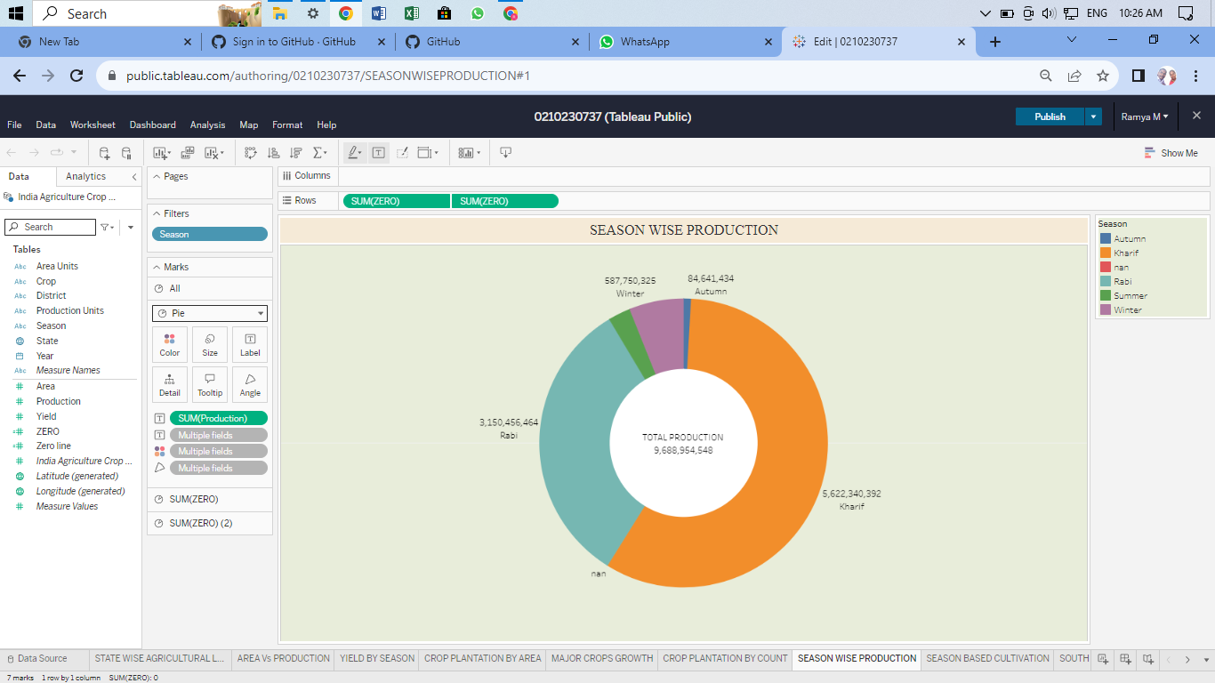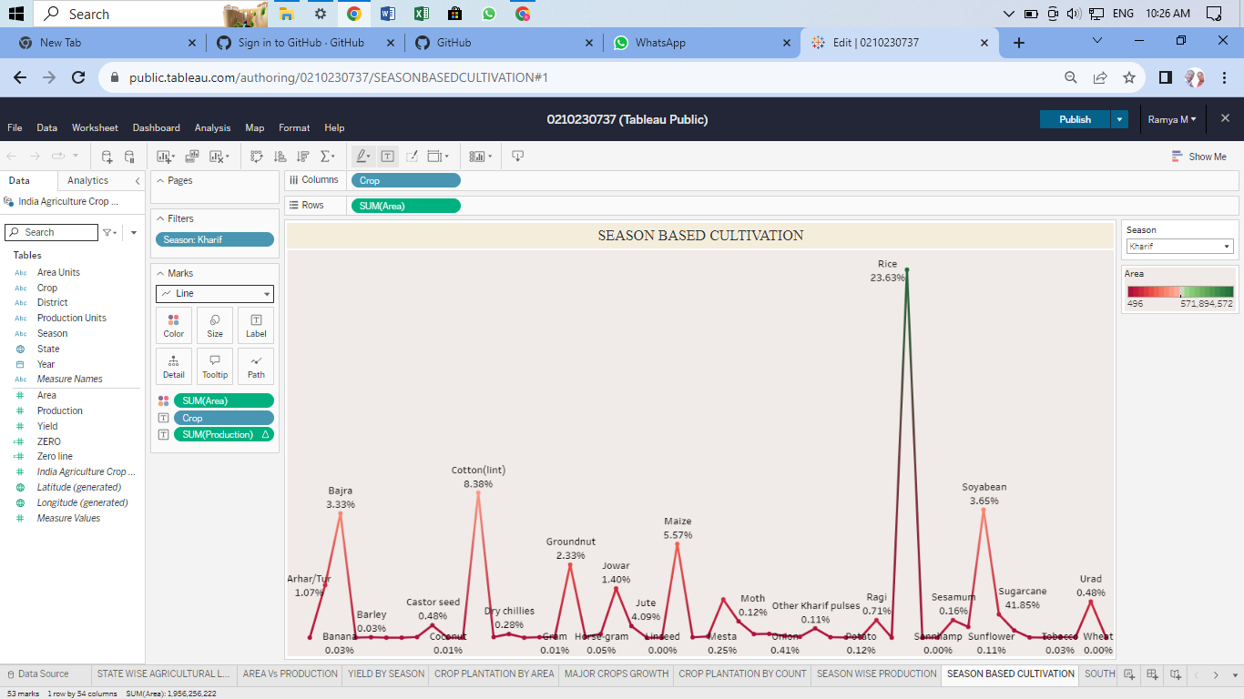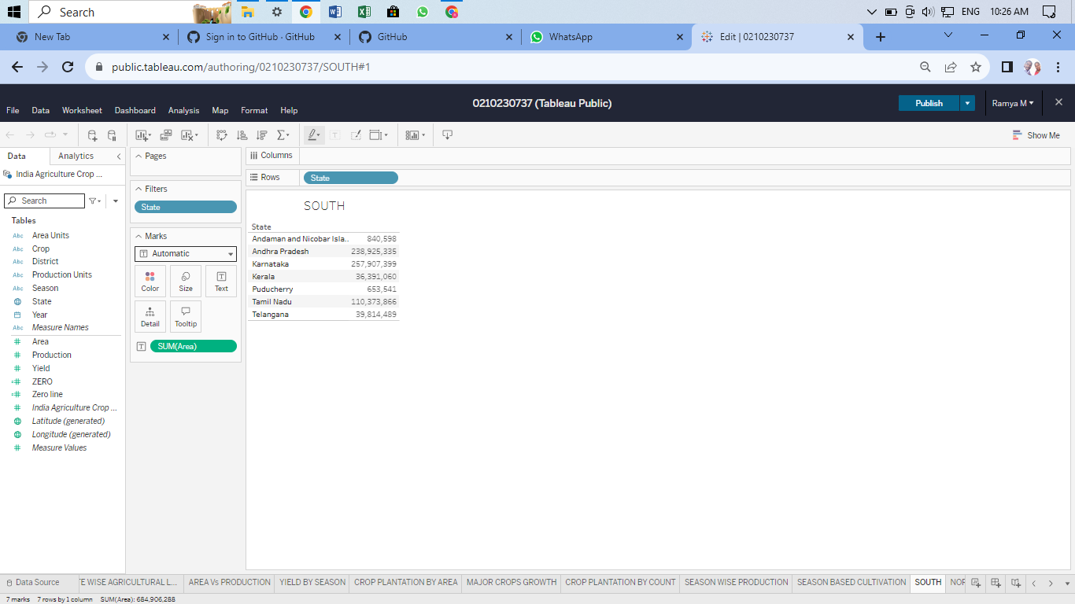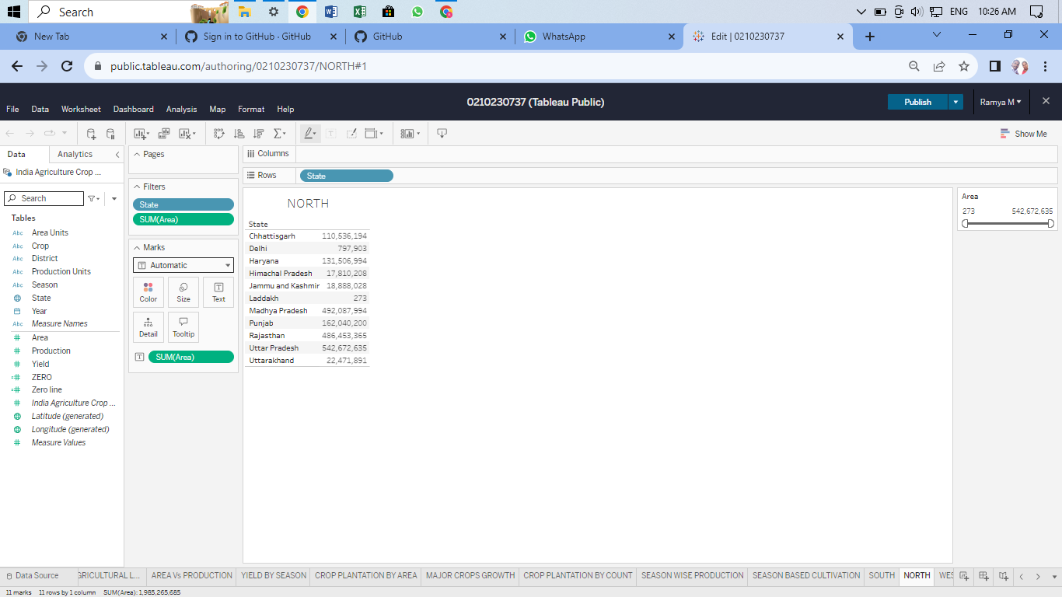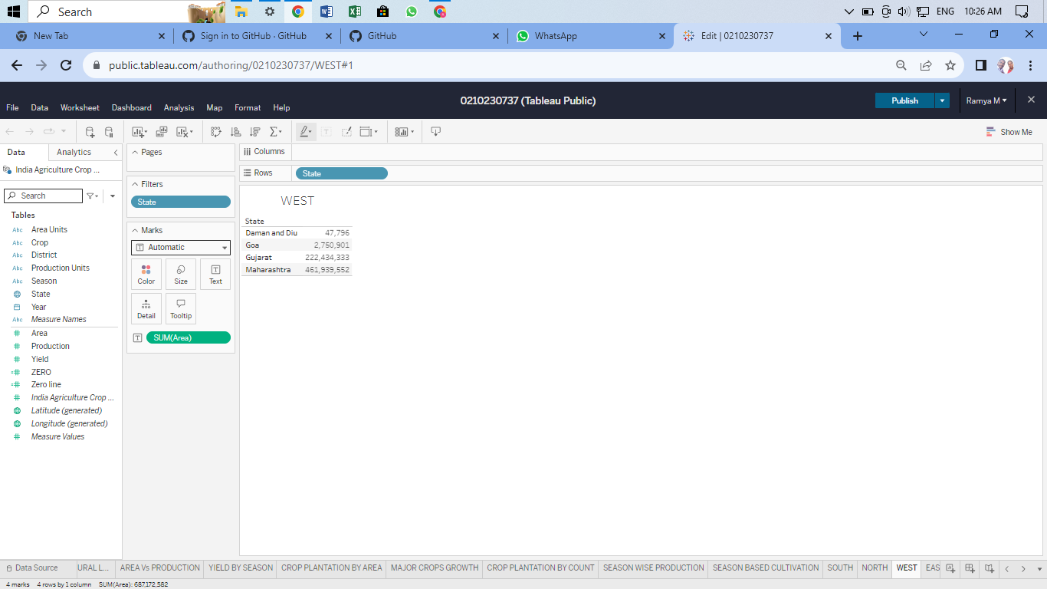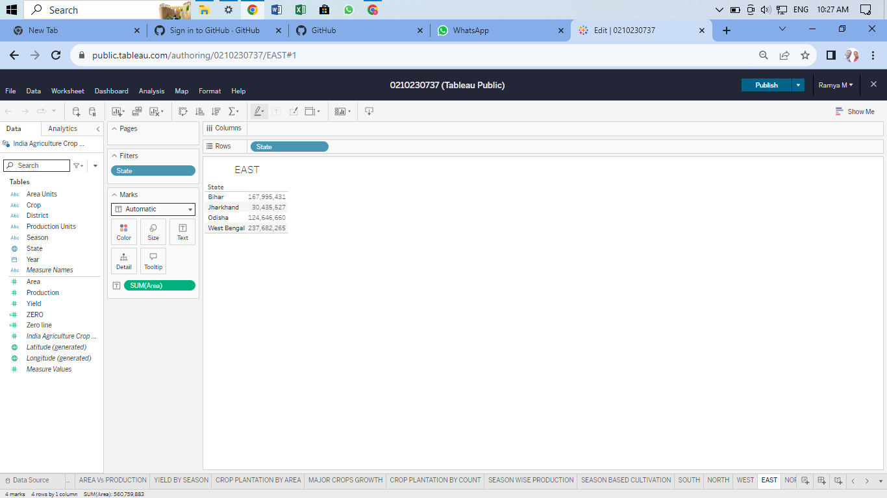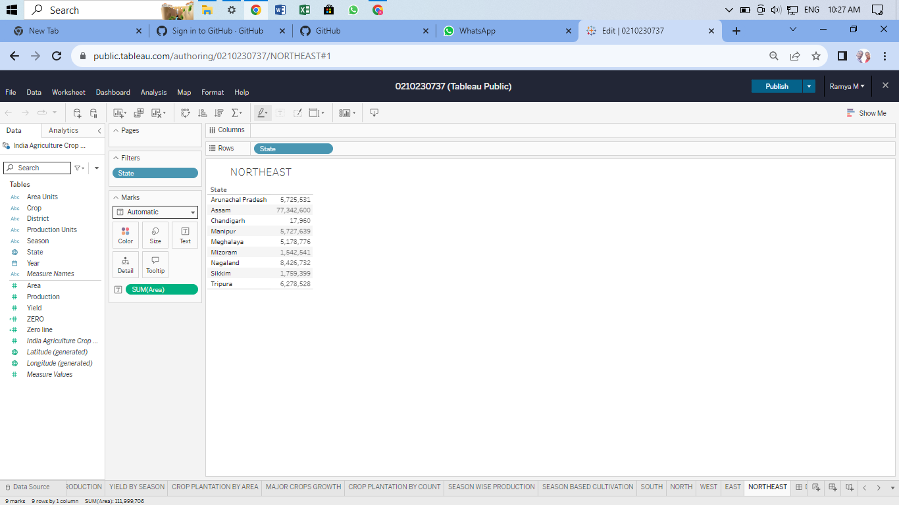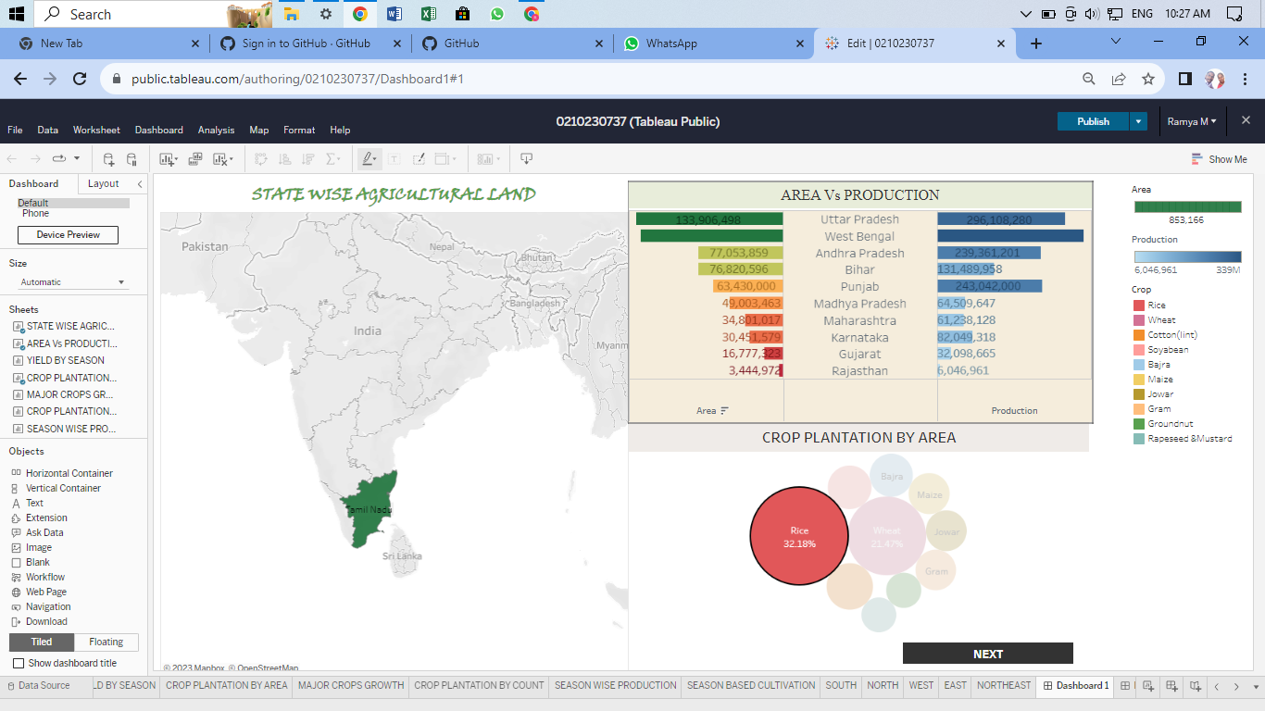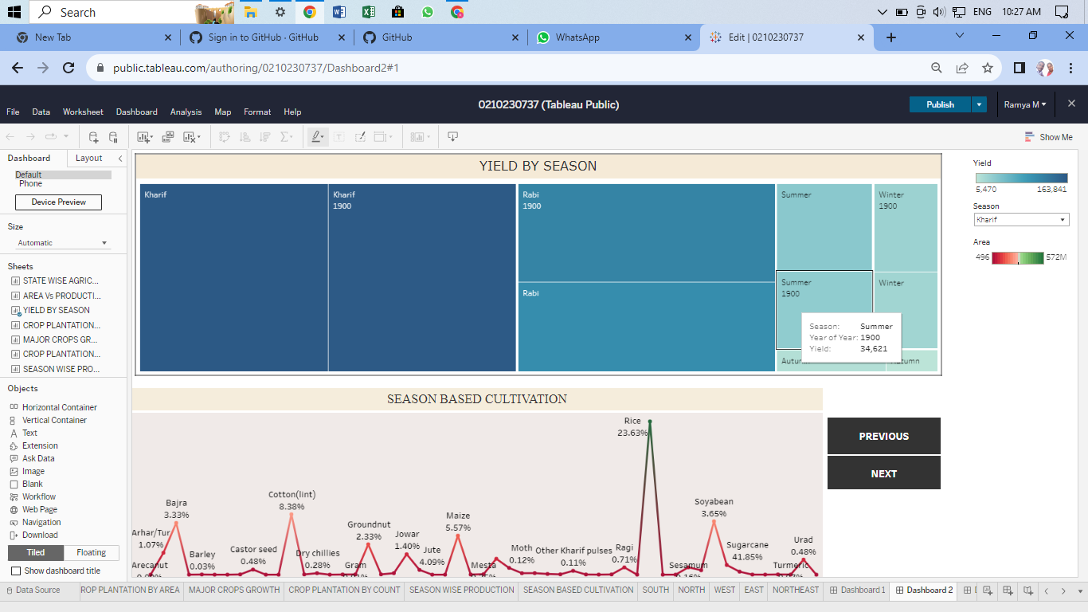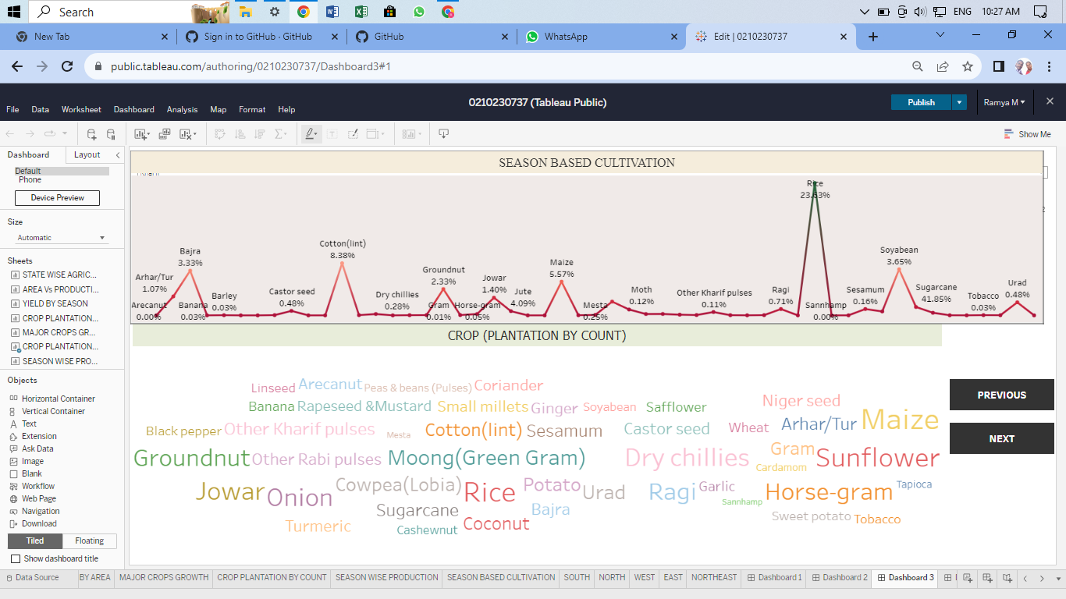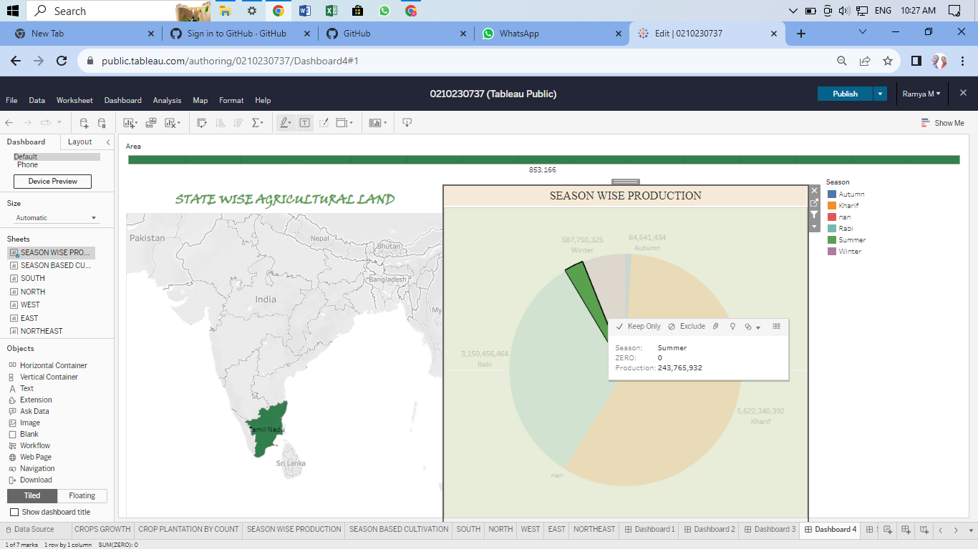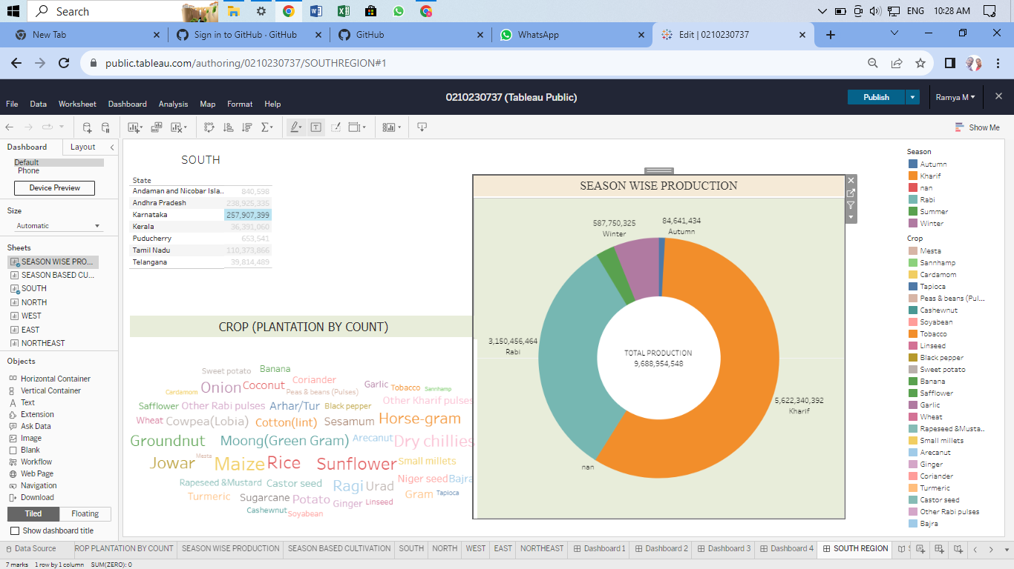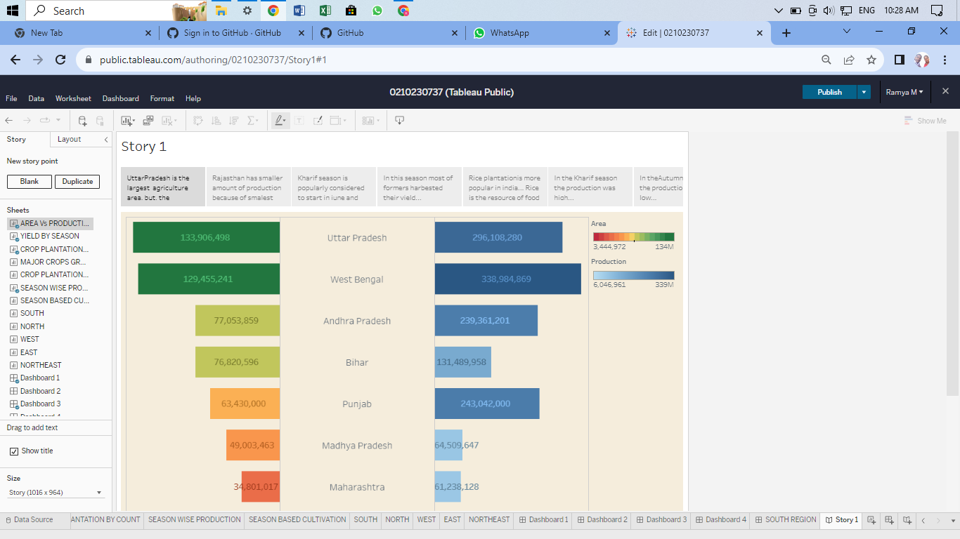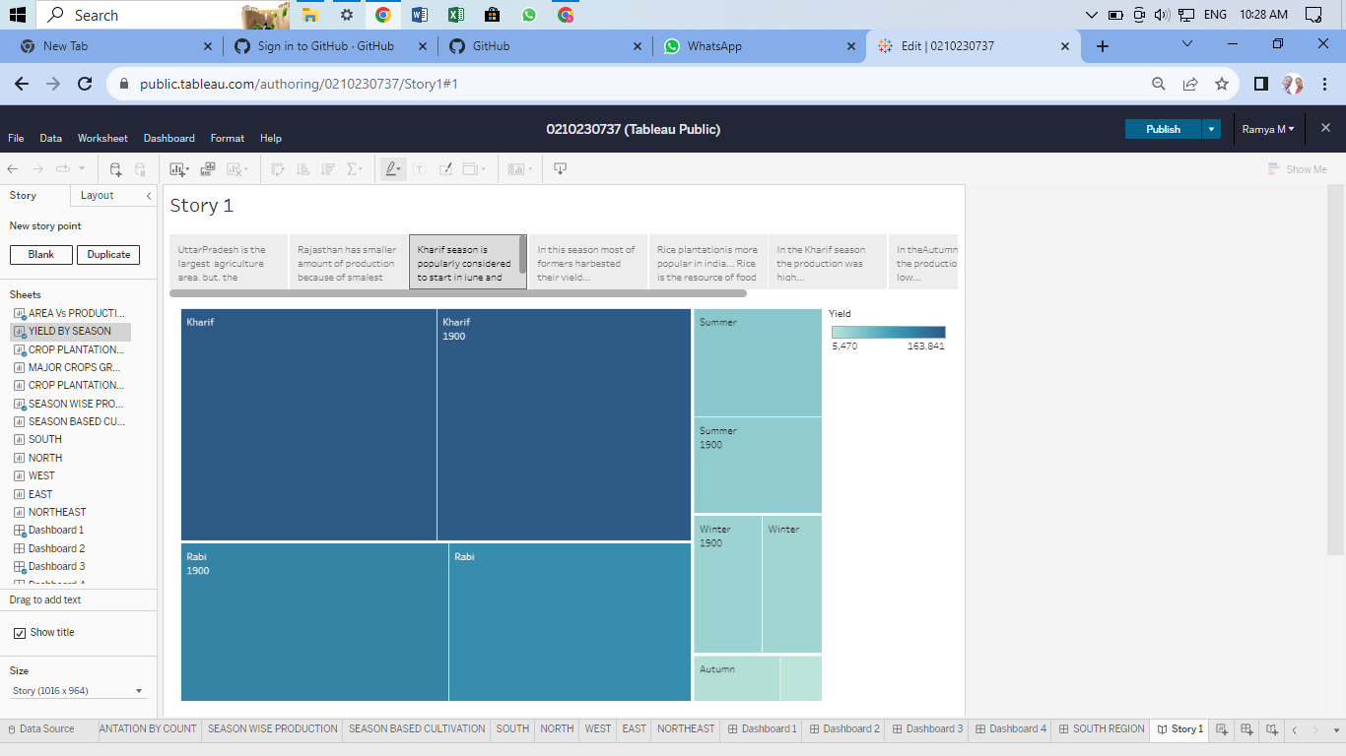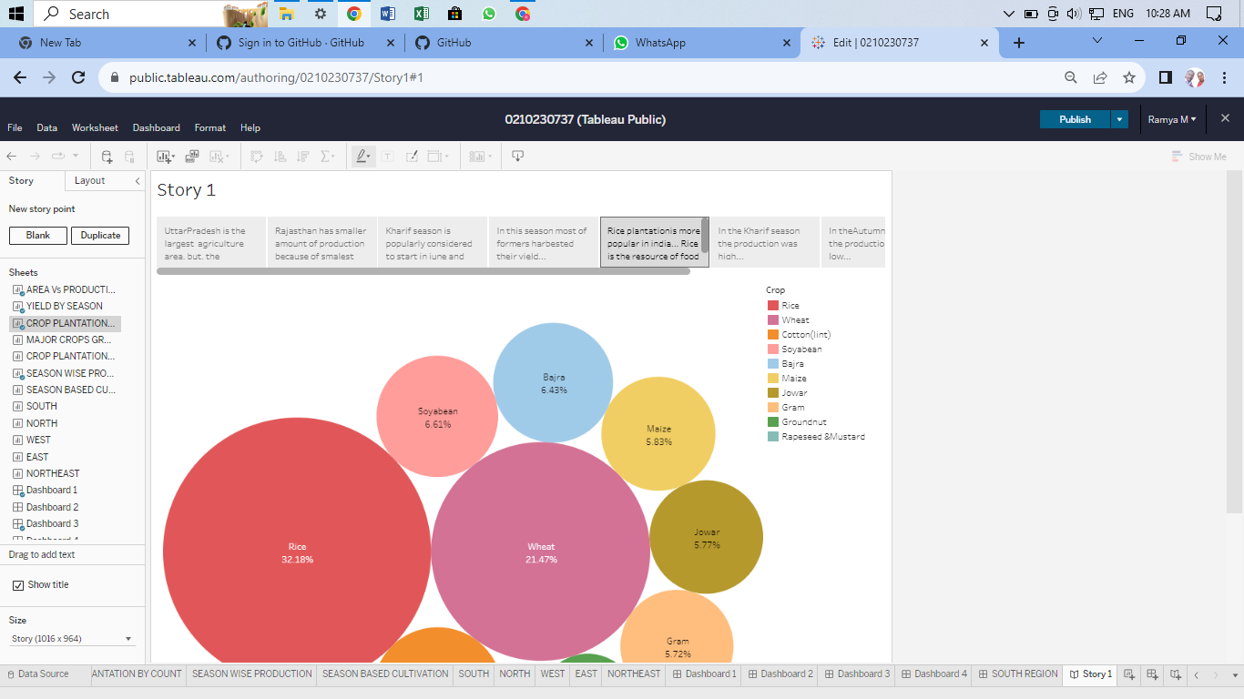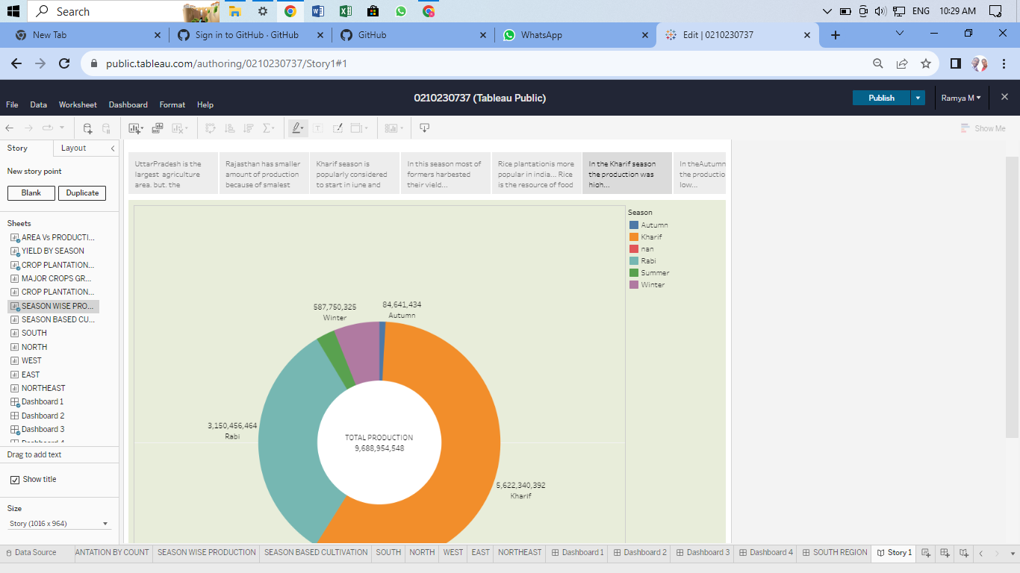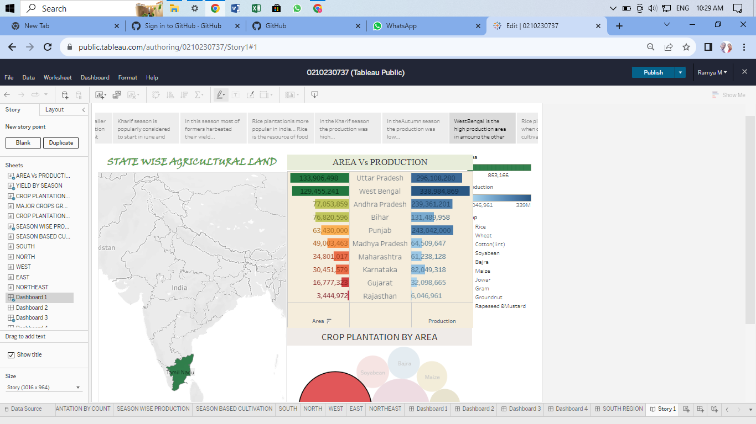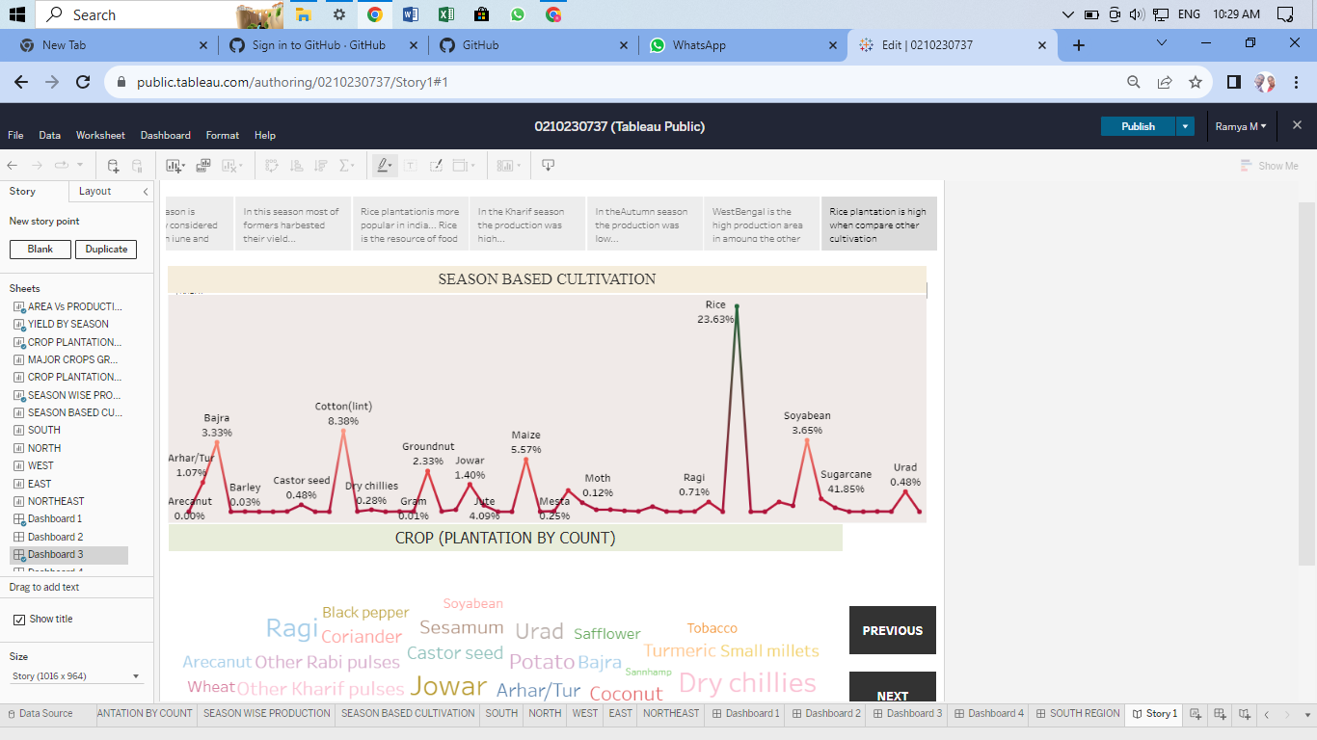

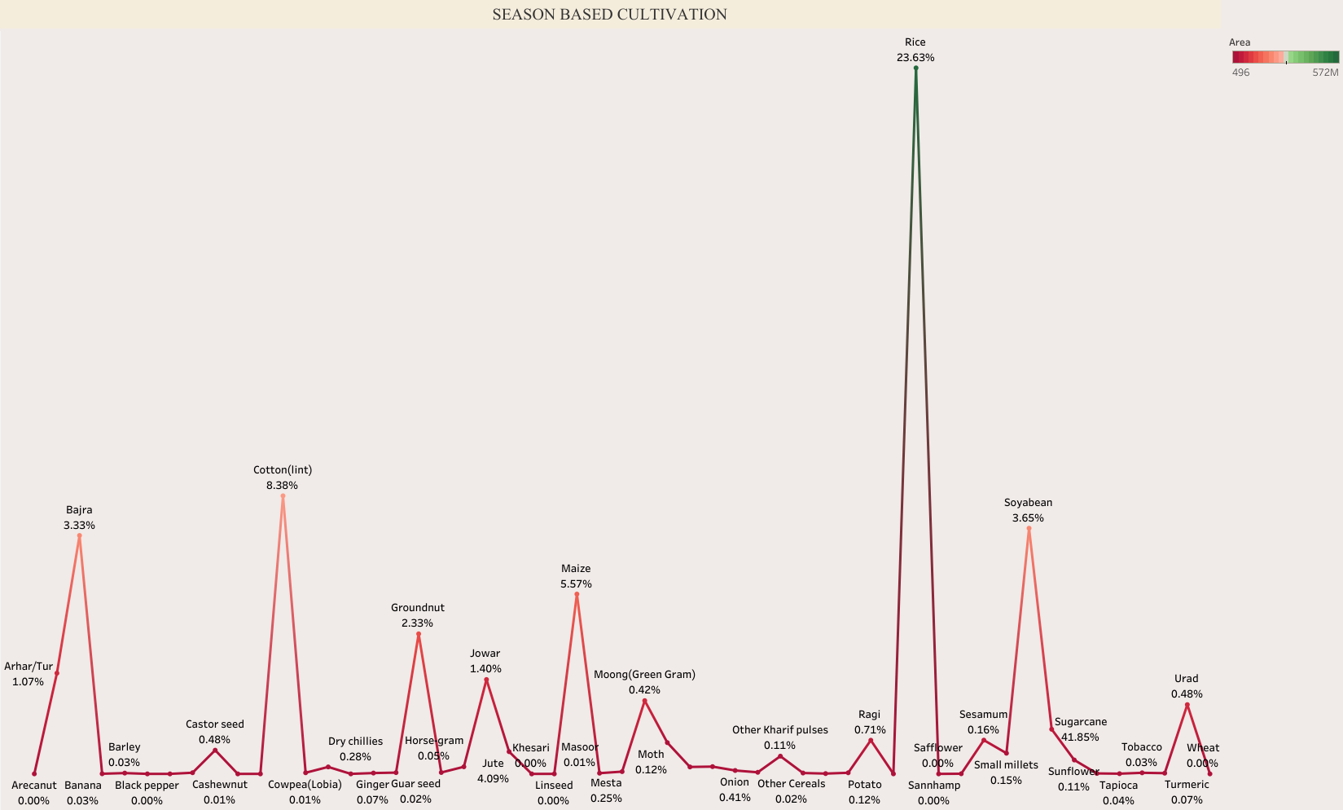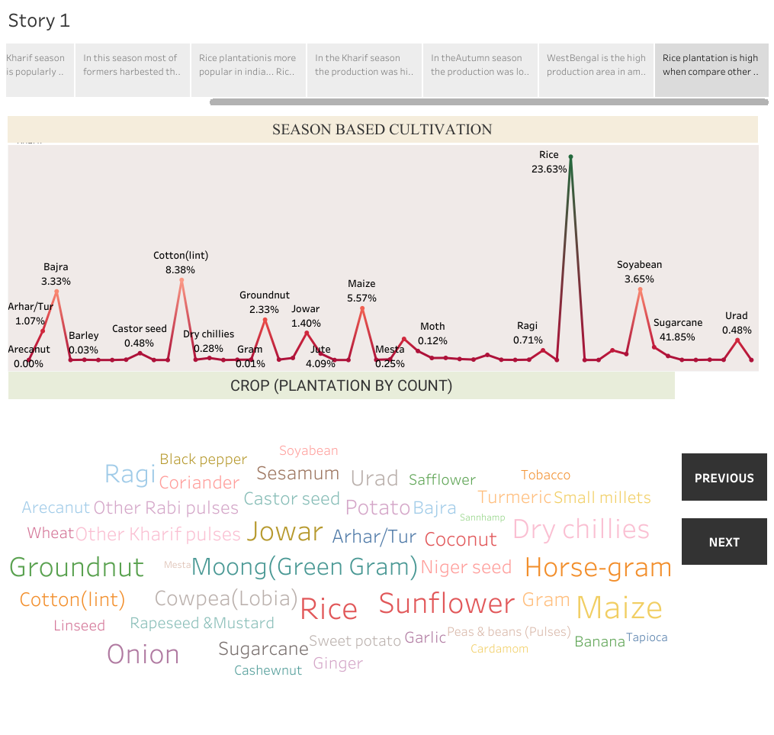

Public : <https://public.tableau.com/shared/7CSPB2TQM?:display_count=n&:origin=viz_share_link>

GitHub Link : <https://github.com/mtcasmathsst94/Indias-Agricultural-Crop-Production-Analysis-1997-2021-_NM2023TMID13757>